Basic statistics

.
What is statistics?
A.L. Bowley defined statistics as
‘Statistics may be called the science of counting’.
A definition due to W.I. King is

‘Statistics may be defined as the science of collecting, organizing, presenting, analyzing, , interpreting numerical data and making valid inferences or conclusion on the base of the data.’

Basically there are three steps involved in statistics:
1) Specification of the information required to achieve the objectives
of the study;
2) Analysis of the information;
3) Interpretation of the results

Types of statistics:

There are two types of statistics
1. Descriptive statistics
2. Inferential statistics.

1. Descriptive Statistics: Descriptive statistics involve graphical and numerical procedures that are used to summarize and process data and to transform data into information.

Example:
A Gallup poll found that 49% of the people in a survey knew the name of the first book of the Bible. The statistic 49 describes the number out of every 100 persons who knew the answer.

2. Inferential Statistics: inferential statistics are used to make inferences about a population from a sample in order to generalize (make assumptions about this wider population) and/or make predictions about the future. Inferential statistics provide the bases for prediction, forecasts and estimates that are used to transform information into knowledge.

Example:
TV networks constantly monitor the popularity of their programs by hiring Nielsen and other organizations to sample the preferences of TV viewer

Some important definitions:

Population: A Population is a Collection of all possible individuals, objects, or measurements of interest.

Sample: A sample is a representative part of the population.
Census: Collection from every member of a population.

Parameter: A Parameter is a measurable characteristic of a population.

Statistic: A statistic is a measurable characteristic of a sample.
Data: Data Any characteristic that can differ from one individual to the next is called a variable. We call variables that are measured, or somehow determined, and collected on a number of individual’s data

Variable: That changes its characteristics with respect to different aspects. Such as height, weight etc.

Qualitative or Attribute Variable the characteristic being studied is nonnumeric. Example: Gender, Eye color, types of Car etc.

In a Quantitative Variable information is reported numerically. Example: Balance in your account, No of children in a family.

Quantitative variables can be classified as either Discrete or Continuous.

Discrete Variables can only assume certain values and there are usually “gaps” between values.
Example: the number of bedrooms in a house, or the number of hammers sold at the local Home Depot (1, 2, 3, etc).

A Continuous Variable can assume any value within a specified range. Example: the weight of a chop, the height of students in a class.

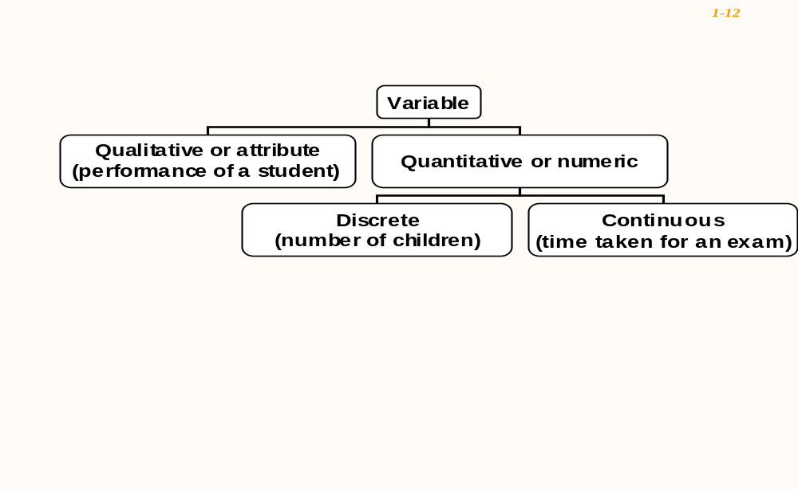

There are four levels of measurements: Nominal, Ordinal, Interval, and Ratio.

Nominal level: Data that is classified into categories and cannot be arranged in any
particular order. Example: Gender, Eye Color etc.

Ordinal level: involves data arranged in some order, but the differences between data values cannot be determined or are meaningless.
During a taste test of 4 soft drinks, Coca Cola was ranked number 1, Dr. Pepper number 2, Pepsi number 3, and Root Beer number 4.

Interval level: Similar to the ordinal level, with the additional property that meaningful amount of differences between data values can be determined. There is no natural zero point.Example: temparature in Fahrenheit scale.

Ratio level: The intervals level with an inherent zero starting point. Differences and ratios are meaningful for this level of measurement. Ex; Monthly income of a family.

Application of Statistics in Computer sciences engineering (CSE):

- Investigate the computational limits of the algorithms and data structures that support complex software systems.
- Develop new applications and tools in multi-disciplinary areas of science and research.
- Explore opportunities for advanced computer modeling and simulation.

